# Day:6 **Animation**

## Downloading animated characters:

marketplace-> search animation -> you can pick an animation starter pack

double click an asset to see animation

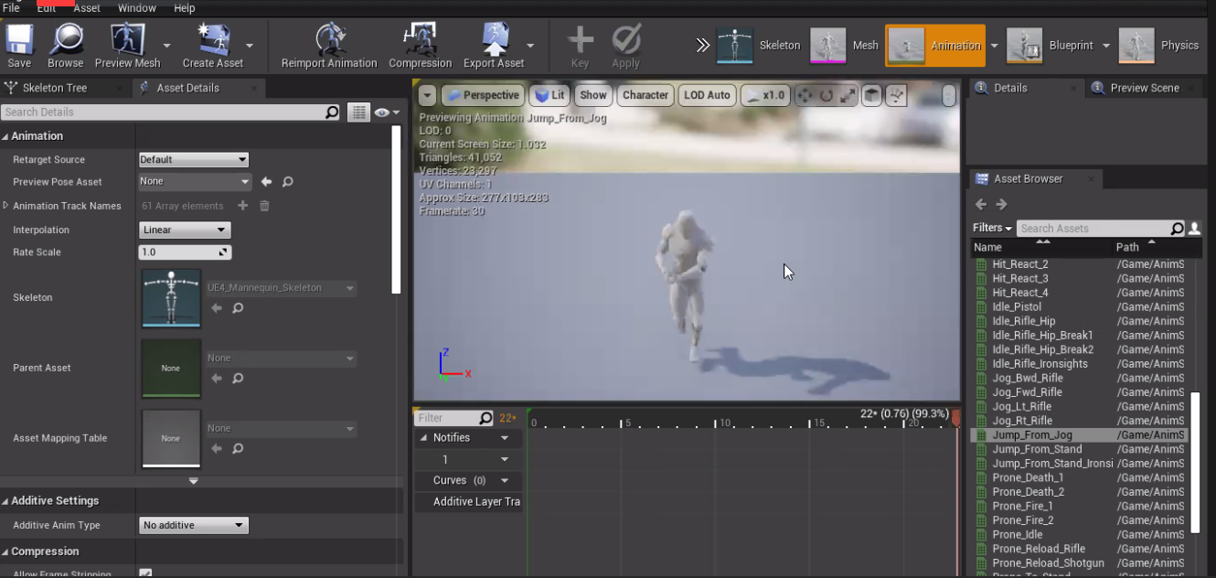

## Configuring Animation:

project setting (over all see of the project)

project setting -> Engine(input) (have all the kets)

action mappings: perform any actions

axis mappings: movements

action mappings (plus sign)-> select key

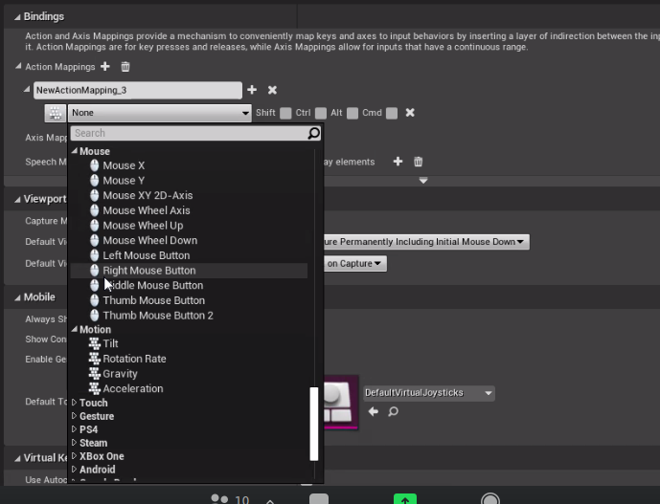

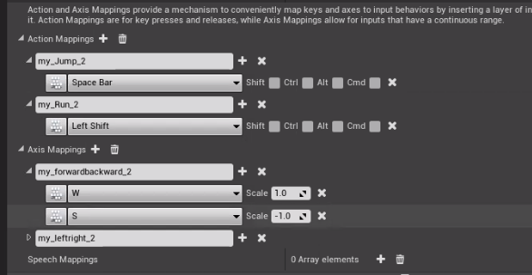j

## Creating a blue print for Character

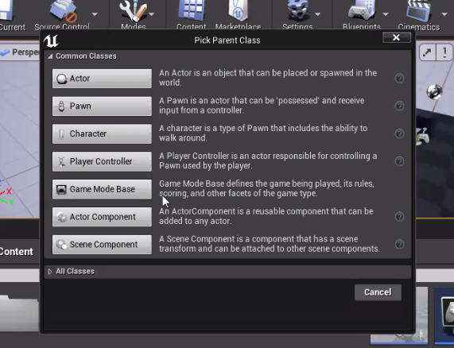

click -> blue print and pick parent class

select meshcharacter and

compile -> save

goto event graph: here you'll use all the keys we saved for aimation

## Creating a Game World

search camera and add it

goto world setting-> right click blue print -> game mode base-> save the blue print

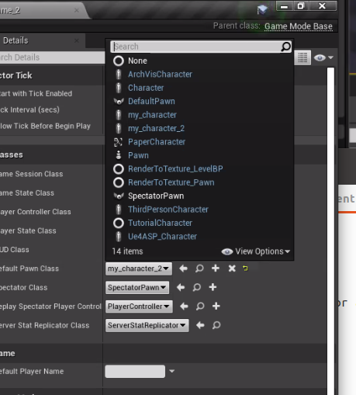

goto default pawn class and select your clear

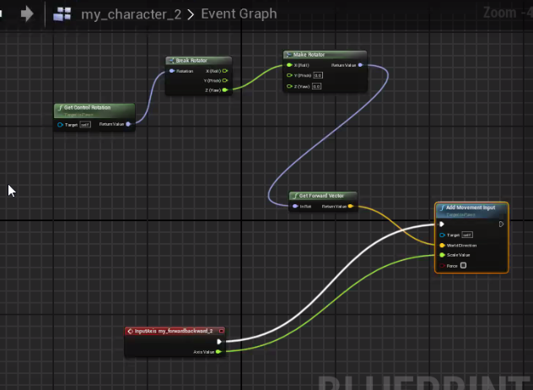

goto your character blue print -> right click -> (search your animation reference here)

right click -> add movements

right click -> get control rotation (to add wold direction)

marketplace → learn → get the cources